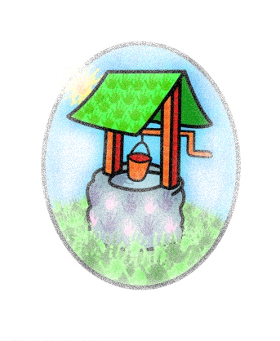
JACK … where children can explore, create and discover the colour of dreams

Childhood Obesity Strategy

The government’s Childhood Obesity Strategy aims to reduce England’s rate of childhood obesity over the next ten years.
Today nearly a third of children aged 2 to 15 years are overweight or obese and younger generations are becoming obese at earlier ages and staying obese longer into adulthood.
Not only is obesity linked with conditions such as type 2 diabetes and heart disease; but the economic costs are high too. We are spending more each year on the treatment of obesity and diabetes than we do on the police and fire service combined!

The plans outlined in the strategy include:
- Setting targets for food manufacturers to cut sugar in the foods that children eat the most, by reducing sugar content in products, reducing portion sizes or shifting consumer choice towards lower sugar alternatives.
- Helping all children to enjoy an hour of physical activity every day, either through PE, extracurricular clubs, active lessons or other sports and physical activities in school
- One of the key pledges is to help improve school / pre-school food.

Jack and Jill’s food policies are designed to support this strategy and give children ‘skills for life’ in relation to their eating habits.

Thank you for your support and helping us build a healthier future for our children

