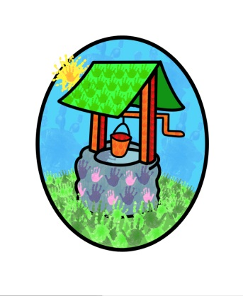
JACK … where children can explore, create and discover the colour of dreams

Promotion of British Values:

The fundamental British values of democracy, rule of law, individual liberty, mutual respect and tolerance for those with different faiths and beliefs are embedded in the Early Years Foundation Stage (2014).
To demonstrate what this means in our day-to-day practice we have drawn up a few examples:

Democracy: Making decisions together
As part of the focus on self-confidence and self-awareness as cited in Personal, Social and Emotional Development:
- Children will be encouraged to see their role in the bigger picture, encouraging them to know their views count, value each other’s views and values and talk about their feelings.
When appropriate they will be supported to demonstrate democracy in action, sharing views and making collective decisions with adults and other children in the setting.
- Where appropriate staff will support the decisions children make and provide activities that involve turn taking, sharing and collaboration.
Children will be given opportunities to develop enquiring minds in an atmosphere where questions are valued

Rule of Law: Understanding rules matter
As part of the focus on managing feelings and behaviour as cited in Personal, Social and Emotional Development:
- Staff ensure that children understand their own and other’s behaviour and its consequences, and learn to distinguish right from wrong.
- Staff collaborate with children to create the ‘rules’ and codes of behaviour and understand that rules apply to everyone

Individual Liberty: Freedom for all
As part of the focus on self-confidence and self-awareness and people and communities as cited in Personal, Social and Emotional Development and Understanding the World:
- Children are encouraged to develop a positive sense of themselves. Children are provided with opportunities to develop their self-knowledge, self-esteem and increase confidence in their own abilities.
- Children are encouraged to explore a range of experiences that support exploration of the language of feelings and responsibility, reflect on their differences and understand we are free to have different opinions.

Mutual Respect and Tolerance: Treat others as you want to be treated
As part of the focus on people and communities , managing feelings and behaviour and making relationships as cited in Personal, Social and Emotional Development and Understanding the World:
- We have an ethos of inclusivity and tolerance where views, faiths, cultures and races are valued and children are engaged with the wider community.
- Children are encouraged to acquire a tolerance and appreciation of and respect for their own and other cultures; know about similarities and differences between themselves and others and among families, faiths, communities, cultures and traditions and share celebrations and experiences.
- Staff encourage and explain the importance of tolerant behaviours such as sharing and respecting others opinions
- We promote diverse attitudes and challenge stereotypes, providing resources and activities that challenge gender, cultural and racial stereotyping.

This policy was adopted by Jack & Jill Pre-school at a meeting held on:

It is signed on behalf of the setting by:

In their capacity as: Chairperson

