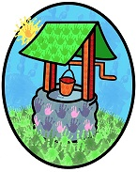**Jack and Jill Childcare**

**Packed Lunch Policy**

At Jack and Jill Childcare we promote and encourage health and well-being.

**We follow the food and drink guidelines set out by “Early Years Foundation Stage nutrition guidance for group and school-based providers and childminders in England May 2025”**

**Legislation this publication refers to:**

**The EYFS safeguarding and welfare requirements are given legal force by Regulations1 made under section 39(1)(b) of the Childcare Act 2006.**

There are many great opportunities to encourage and support children to eat well.

If you provide balanced, varied, and nutritious Packed lunches, it will help us to teach positive and appropriate eating habits to aid children through to adult life.

**We also encourage regular physical exercise as this combined with a healthy, balanced, and nutritious diet is important for the growth and development of young children. It is also essential for children’s health and well-being – please see our healthy start statement.**

Children with food allergies will need to provide written documentation from a healthcare professional detailing the child’s allergy, severity, and allergy action plan.

**Children with dietary requirements will need to provide written documentation from a healthcare professional detailing the child’s dietary needs.**

We can also accommodate children cleaning their teeth after meals, please let us know if you would like this to be an option for your child(ren). Please also provide a named toothbrush and named toothpaste in a named waterproof container in their school bag each day.

**This Policy has been written in accordance with the government guidelines set out in the “Early Years Foundation Stage nutrition guidance for group and school-based providers and childminders in England May 2025”. The packed lunch policy runs alongside our food policy.**

**It is extremely important you follow this guidance so we can all play our part in safeguarding children with allergies, along with ensuring all children are being provided with healthy, balanced, and nutritious meals that are also compliant with food health and hygiene regulations.**

**Please provide:**

* A NAMED and INSULATED LUNCHBAG (all food must fit within this bag)
* **The bag MUST CONTAIN AN ICE PACK (to adhere to food safety and hygiene regulations)**
* A NAMED drink bottle FILLED WITH WATER ONLY (this can be their daytime water bottle)
* **Food must be suitable to consume straight from the lunch box (we will not re-heat or cook food you provide)**
* Food must be prepared appropriately for your child’s age, stage and individual needs (to avoid choking-please see information below)
* **Food must not contain NUTS (we are a nut free setting)**
* When preparing food, please be mindful of allergens that could be accidently transferred to items you put in your child’s packed lunch bag.
* 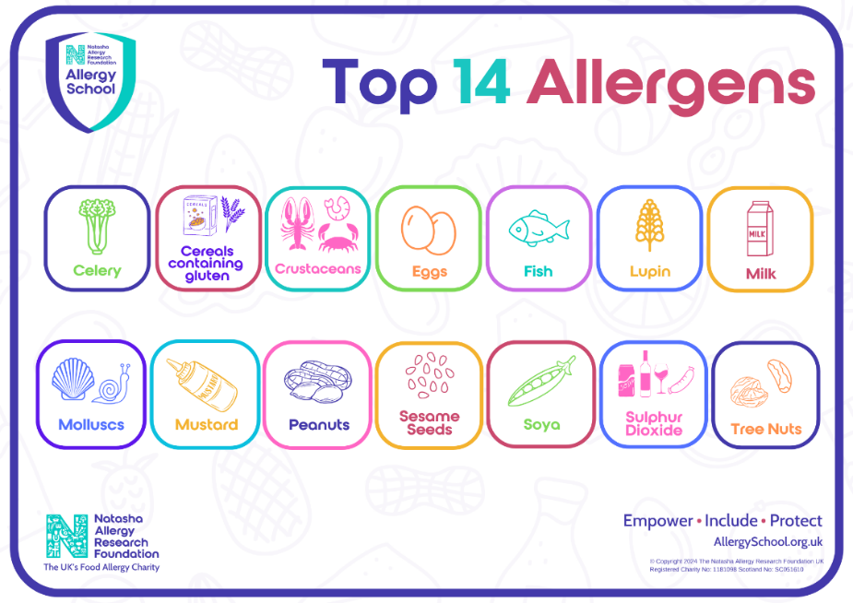**If you put any FOOD CONTAINING ONE OR MORE of the TOP 12 ALLERGENS (PEANUTS & TREE NUTS ARE NOT PERMITTED) in your child’s lunch, it would be extremely helpful to pop a note inside the bag so I can assess the risk, should we have a child with allergies on site.**

**Other prohibited items: (included but not limited to…)**

**Chocolate spread**

**Fizzy drinks and squash/juice**

**Sweets and chocolate**

**Joanne Allen has responsibility for this food policy on behalf of Jack and Jill Childcare.**

Date of policy implementation: 03/09/2025

*This policy was adopted by Jack & Jill Childcare on:* ***1st August 2025***

*It is signed on behalf of the setting by:* ***Lynne Batchelor***

*In their capacity as:* ***Chairperson***

**Lunchbox tips**

<https://www.nhs.uk/healthier-families/recipes/healthier-lunchboxes/#tips>

**Keep them fuller for longer**

Base the main lunchbox item on foods like bread, rice, pasta and potatoes. Choose wholegrain where you can.

**Freeze for variety**

Keep a small selection of different types of bread in the freezer so you have a variety of options – like bagels, pittas and wraps, granary, wholemeal and multigrain.

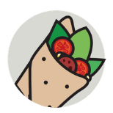**DIY lunches**

Wraps and pots of fillings can be more exciting for kids when they get to make them. Dipping foods are also fun and a nice change from a sandwich each day.

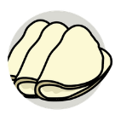**Cut back on fat**

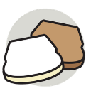Pick lower-fat fillings – like lean meats (including chicken or turkey), fish (such as tuna or salmon), lower-fat spread, reduced-fat cream cheese and reduced-fat hard cheese. And try to avoid using mayonnaise in sandwiches.

**Mix your slices**

If your child does not like wholegrain, try making a sandwich from 1 slice of white bread and 1 slice of brown bread.

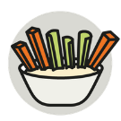**Always add veg**

Cherry tomatoes, or sticks of carrot, cucumber, celery and peppers all count towards their 5 A Day. Adding a small pot of reduced-fat hummus or other dips may help with getting kids to eat vegetables.

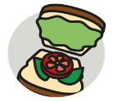**Ever green**

Always add salad to sandwiches and wraps too – it all counts towards your child's 5 A Day!

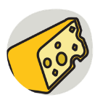**Cheesy does it…**

Cheese can be high in fat and salt, so choose stronger-tasting ones – and use less of it – or try reduced-fat varieties.

**Cut down on crisps**

If your child really likes their crisps try reducing the number of times you include them in their lunchbox, and swap for homemade plain popcorn or plain rice cakes instead.

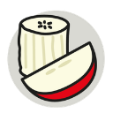**Add bite-sized fruit**

Try chopped apple, peeled satsuma segments, strawberries, blueberries, halved grapes or melon slices to make it easier for them to eat. Add a squeeze of lemon juice to stop it from going brown.

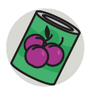**Tinned fruit counts too**

A small pot of tinned fruit in juice – not syrup – is perfect for a lunchbox and easily stored in the cupboard.

**Swap the fruit bars**

Dried fruit like raisins, sultanas and dried apricots are not only cheaper than processed fruit bars and snacks but can be healthier too. Just remember to keep dried fruit to mealtimes as it can be bad for teeth.

**Switch the sweets**

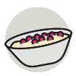Swap cakes, chocolate, cereal bars and biscuits for malt loaf, fruited teacakes, fruit breads or fruit (fresh, dried or tinned – in juice not syrup).

**Yoghurts: go low-fat and lower-sugar**

Pop in low-fat and lower-sugar yoghurts and add your own fruit.

**Get them involved**

Get your kids involved in preparing and choosing what goes in their lunchbox. They are more likely to eat it if they helped make it.

**Variety is the spice of lunch!**

Be adventurous and get creative to mix up what goes in their lunchbox. Keeping them guessing with healthier ideas will keep them interested and more open to trying things.

**Plan to Eatwell**

The guide shows how much of what we eat overall should come from each food group to achieve a healthy, balanced diet. It can be really useful when thinking about what goes into kids' lunchboxes.

[The Eatwell Guide](https://www.nhs.uk/live-well/eat-well/the-eatwell-guide/)





|  |  |
| --- | --- |
| **Vegetable and fruits** | **Advice** |
| Pips or stones in fruit | Always check beforehand and remove hard pips or stones from fruit. |
| Small fruits | Cut small round fruits like grapes, cherries, berries, strawberries and cherry tomatoes, into small pieces: cut lengthways and then again cut them in halves (quarters). |
| Large fruits and firm fruits | Cut large fruits like melon and firm fruits like apple into slices instead of small chunks. For very young children, consider grating or mashing firm fruits, or softening them up by steaming or simmering. |
| Vegetables | Cut vegetables like carrots, cucumber and celery into narrow batons. For very young children consider grating or mashing firm vegetables and legumes like butter beans, chickpeas and tofu, or softening them up by steaming or simmering. |
| Skin on fruit and vegetables | Consider removing the skin from fruit and vegetables, especially for very young children. Peeled fruit and vegetables can be swallowed more easily. |
| Cooking fruit and vegetables | Consider softening firm fruit and vegetables (such as carrots, broccoli, yam and apples) by steaming or simmering until soft. Serve cut into slices or narrow batons. |
| **Meat and fish** | **Advice** |
| Sausages and hot dogs | Cut sausages and hot dogs into short strips. Cut them in half and then lengthways or as thinly as possible. Peeling the skin off the sausages helps them to be swallowed more easily. |
| Meat or fish | Remove bones from meat or fish. Cut meat into strips as thinly as possible. Remove skin and fat from meat and fish, it will help the food pass smoothly down the throat. |

|  |  |
| --- | --- |
| **Cheese** | **Advice** |
| Grate or cut cheese | Grate or cut cheese into short strips. Cut lumps of cheese as narrow as possible. |
| **Nuts and seeds** | **Advice** |
| Chop or flake whole nuts | Chop or flake whole nuts, peanuts and seeds. Whole nuts should not be given to children under five years old. |
| **Bread** | **Advice** |
| White bread and other breads | White bread can form a ball shape with a dough-like texture at the back of a child's throat, if not chewed properly. Brown bread or toasted white bread are good alternatives. Cut bread, chapatis, naan bread and other breads into narrow strips. |
| **Snacks and other foods** | **Advice** |
| Popcorn | Do not give babies and young children popcorn. |
| Chewing gum and marshmallows | Do not give babies and young children chewing gum or marshmallows. |
| Peanut butter | Do not give babies and young children peanut butter on its own, only use as a spread. |
| Jelly cubes | Do not give babies and young children raw jelly cubes. |
| Boiled sweets and ice cubes | Do not give babies and young children boiled, hard, gooey, sticky or cough sweets, or ice cubes. |
| Raisins and other dried fruits | Do not give babies under the age of 1 whole raisins or dried fruits. Cut them into small pieces. |

Make sure food is prepared appropriately for children under 5 years old, see: <https://www.nhs.uk/start4life/weaning/>It is also advisable that care givers are familiar with how to respond to a choking incident, see: How to stop a child from choking:<https://www.nhs.uk/conditions/baby/first-aid-and-safety/first-aid/how-to-stop-a-child-from-choking/>[and How to resuscitate a child: https://www.nhs.uk/conditions/baby/first-aid-and-safety/first-aid/how-to-resuscitate-achild/](https://www.nhs.uk/conditions/baby/first-aid-and-safety/first-aid/how-to-resuscitate-a-child/)