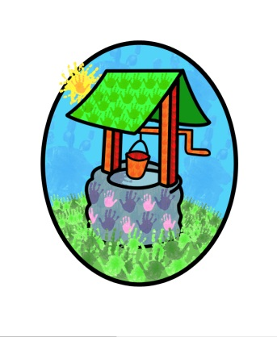

JACK … where children can explore, create and discover the colour of dreams

Parent Participation Policy:

Parents are the primary educators of their children & the aim of Jack & Jill is to support their essential work, not to displace them.

To enable this we will:
- Make all parents aware of our systems & policies
- Encourage & support individual parents to play an active role in the ‘life’ of the setting.
- Encourage & support individual parents to play an active role in the management of the setting.
- Ensure that parents are informed on a regular basis about their child’s progress
- Facilitate a system that supports a two-way flow of information between the setting & the family.
- Ensure that all parents have opportunities to contribute their own skills, knowledge & interests to the activities of the setting.
- Involve parents in shared record keeping, on a formal & informal basis.
- Have a flexible approach to consulting with families
- Hold meetings / events in venues which are accessible & appropriate to avoid exclusion from attending.
- Welcome the contributions from parents, whatever form they may take
- Make information about queries, suggestions & complaints available.
- Provide opportunities for families to extend their knowledge of the EYFS, our curriculum & children’s learning both in the setting & at home.
- Provide support, where appropriate, for families dealing with external agencies in relation to their child.

This policy was adopted by Jack & Jill Pre-school at a meeting held on: 1st September 2014

It is signed on behalf of the setting by:

In their capacity as: Chairperson

