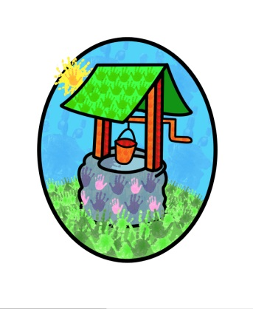
Jack and Jill Childcare … where children can explore, create and discover the colour of dreams

Child-on-Child Abuse / Bullying Policy:

Definition:
There is no clear boundary between bullying and abusive incidents, this is a matter of professional judgement.
If one child causes harm to another, this should not necessarily be dealt with as abuse. Bullying, fighting and harassment between children are not generally seen as child protection issues. However, it may be appropriate to regard young children’s behaviour as abusive if:
- There is a large difference in power between the young people concerned (for example age, size, ability or development)
- The perpetrator has repeatedly tried to harm one or more other children
- There are concerns about the intention of the alleged perpetrator
If the evidence suggests that there was intention to cause severe harm to the victim, this should be regarded as abusive whether or not severe harm was actually caused.

Considerations:
- Children are vulnerable to abuse by their peers, such abuse should be taken as seriously as abuse by adults and be subject to the same child protection procedures.
- Professionals should not dismiss abusive behaviour as normal between young people.
- The alleged perpetrator is likely to have considerable unmet needs as well as posing a significant risk of harm to other children.
Contributing Factors:
- The child may have been physically or emotionally abused themselves
- The child may have witnessed physical or emotional violence
- The child may have viewed violent or explicit images or materials
Protection and Actions:
- Identify blind spots in the setting, recognise these areas and supervise them closely
- Be aware of and recognise patterns of behaviour that see children sneaking off to be alone together and take steps to supervise and separate them.
- Professionals should be attentive and provide supervision at all times.
Professionals should create an environment in the setting which discourages abuse and challenges the attitudes which underlie it.
Any professional who feels that peer-to-peer abuse has taken place should notify the Child Protection Officer in the setting immediately – Diane Shanley. Where appropriate children’s services should be contacted as soon as possible.
Guiding Principles:
- The needs of the victim and the needs of the alleged perpetrator must be considered separately.
- In addition to safeguarding the victim, the risk to other children must be considered.
- Children who abuse others are responsible for their abusive behaviour and any actions must include addressing their behaviour and its causes.
- The alleged perpetrator is likely to have considerable unmet needs as well as posing a considerable risk of harm to other children.
- A co-ordinated approach, involving all appropriate agencies will be needed.

This policy was adopted by Jack & Jill Pre-school at a meeting held on: 16-02-2023

It is signed on behalf of the setting by:

In their capacity as: Chairperson

