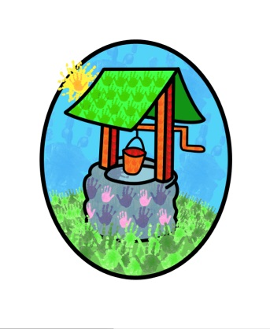

JACK … where children can explore, create and discover the colour of dreams

Meal Policy:
Early Years settings, such as Jack and Jill provide an ideal opportunity to help every child eat well, enjoy a varied diet and establish healthy eating habits to take them into their school years and adult life.
A healthy, balanced diet and regular physical activity are essential for children’s health and well-being. Research confirms that healthy eating habits in the years before school are integral in the promotion of appropriate growth and development.
Good nutrition for children:
- Ensures they get the right amount of energy and nutrients needed while they are growing rapidly.
- Ensures that they do not consume too much energy, which may lead to them becoming overweight or obese
- Encourage them to eat a wide variety of foods and develop good dietary habits to take with them through life.

At Jack and Jill we will provide the children with a healthy, balanced and nutritious diet through our menus. We will provide a variety of different foods from the following food groups to support a better balance of nutrients:
- Starchy Foods
- Fruit and Vegetables
- Meat, fish, eggs, beans and other non-dairy sources of protein
- Milk and dairy foods
- Foods providing higher sources of fat and sugar – these are needed in the diet to ensure enough energy is provided but we will monitor these carefully to ensure that appropriate levels of saturated fat, sugar and salt are not exceeded.
The menu will be published via our electronic mailing service and the website to ensure parents are kept informed of the foods their child is being offered. In addition parents are welcome to request notification of what their child has eaten each day.

We will endeavour to provide ‘food for all’ and ensure that children following special diets for health, cultural or religious reasons are catered for and managed appropriately and effectively.
Fussy eating and fear of new foods are a common part of children’s development, we will support these children to have a positive approach to new foods.
Cooking with children is an effective way to encourage children to have a positive approach to foods and to try new ones. At Jack and Jill the children are actively encouraged to be involved in the preparation and cooking processes involved in making their meals.
Food is stored, prepared and presented in a safe and hygienic environment and children are taught basic hygiene practices.

In developing our practices with regards to food planning, buying, preparation, cooking and eating Jack and Jill takes regard of the following documents:
- Eat Better Start Better: Voluntary Food and Drink Guidelines for Early Years Settings in England – A Practical Guide
- Safer Food, Better Business for caterers.

Staff involved in the storage, preparation and cooking of food on our premises will complete appropriate training regularly.
Jack and Jill will adhere to the advice, and facilitate inspection from the local Environmental Health Department.

This policy was adopted by Jack & Jill Pre-school at a meeting held on: 10th July 2015

It is signed on behalf of the setting by:

In their capacity as: Chairperson

