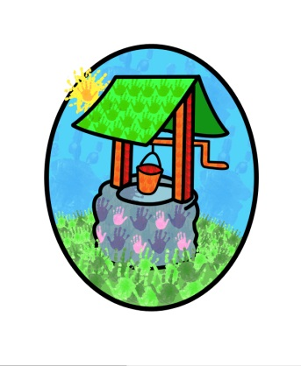
Jack and Jill Childcare … where children can explore, create and discover the colour of dreams

Admission Policy:

“Pre-schools – a place for everyone”

We operate a dual action waiting list, whereby the child’s date of birth & individual needs are assessed & considered in conjunction with the timing of the application submission. All these aspects determine the child’s place on our waiting list & therefore the date of their admission.

All children are considered equally for a place, regardless of:
Gender / class / family status / disability / colour / ethnic origin / culture / religion or belief

Children become eligible to start attending the group from the age of ‘rising’ two-years.
Parents are able to express a preference for the setting they setting they would like their child to attend, but we reserve the right to assess each case individually and place the child in the most appropriate setting.

Contributing factors:
- Ofsted guidelines on the floor area available within the setting and applied space allocation per child.
- Current calculations allow 34 children in each session at Littlehaven and 28 children in each setting at Northolmes (ratios permitting)
- Adult to child working ratios: 1:3 @ 1 year / 1:5 @ 2 years / 1:8 @ 3 – 8 years / 1:12 @ 8-12 years – these ratios must be adhered to at all times.

Promotion & marketing:
We will endeavour to promote our provision throughout the community, to ensure that we are available to all.

Attendance at Jack and Jill does not in any way influence future attendance at Littlehaven Infant School or Northolmes Junior School

This policy was adopted by Jack & Jill Pre-school at a meeting held on: 5th July 2023

It is signed on behalf of the setting by: L Batchelor

In their capacity as: Chairperson

