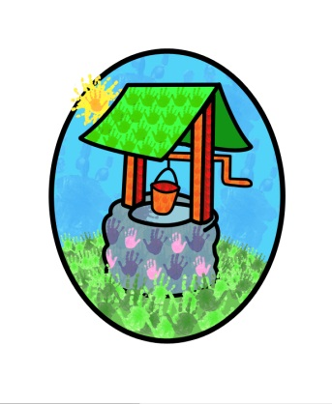

Jack and Jill Pre-school… where children can explore, create
and discover the colour of dreams

Free Entitlement Policy:

Free entitlement (FE) pays for 15 hours per week for a maximum of 38 weeks a year.

Children become eligible to receive the FE from the start of the term following their third birthday until they reach statutory school age.

A Child born between: | Will be eligible from:
1st April & 31st August | Start of Autumn term
1st September & 31st December | Start of spring term
1st January & 31st March | Start of summer term

Children must be attending the setting prior to headcount day (usually in the first two weeks of the start of term) to be eligible.

In order to receive FE we will ask you to complete & sign a parent declaration form, providing proof of your child’s date of birth. Any changes must be agreed prior to headcount day to be eligible as part of the FE.

Families meeting certain criteria may be able to apply for 15 hours free entitlement for two-year-olds. Check www.westsussex.gov.uk/freechildcare

Eligible children are able to access up to 30 hours free entitlement, take a look at the website www.childcarechoices.gov.uk for details.

At Jack & Jill our sessions run to provide flexible childcare and education, and spaces permitting children are able to access sessions of 1, 2, 3, 4, 5, 6, 7 or 8 hours. Once eligible your child is able to have up to 15 hours free of charge, with the minimum session length being 2 ½ hours.
Additional costs are applied for ad hoc sessions, workshop sessions, holiday club sessions and membership of the setting.
Some families may be able to access funding for two-year-olds, please ask the setting for details of eligibility and how to apply.

This policy was adopted by Jack & Jill Pre-school at a meeting held on: 13th July 2016

It is signed on behalf of the setting by:
In their capacity as: Chairperson

