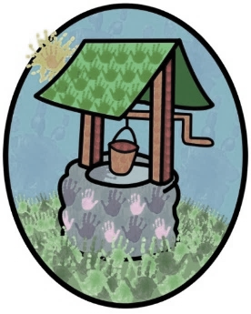
Jack and Jill Childcare

Early Years Booking form (Northolmes)

Child’s name:
DOB:
See notes below/over

Autumn Term ‘23
Monday | Tuesday | Wednesday |  | Thursday | Friday
8-9 | 8-9 | 8-9 |  | 8-9 | 8-9
9-12 | 9-12 | 9-12 |  | 9-12 | 9-12
12-1 | 12-1 | 12-1 |  | 12-1 | 12-1
1-3 | 1-3 | 1-3 |  | 1-3 | 1-3
3-4 | 3-4 | 3-4 |  | 3-4 | 3-4
4-5 | 4-5 | 4-5 |  | 4-5 | 4-5
5-6 | 5-6 | 5-6 |  | 5-6 | 5-6
2yr Funding |  |  | Tax-Free CC

Meals (Please tick if you wish to book a meal)
Breakfast | Lunch | Tea
Spring Term ‘24
Monday | Tuesday | Wednesday |  | Thursday | Friday
8-9 | 8-9 | 8-9 |  | 8-9 | 8-9
9-12 | 9-12 | 9-12 |  | 9-12 | 9-12
12-1 | 12-1 | 12-1 |  | 12-1 | 12-1
1-3 | 1-3 | 1-3 |  | 1-3 | 1-3
3-4 | 3-4 | 3-4 |  | 3-4 | 3-4
4-5 | 4-5 | 4-5 |  | 4-5 | 4-5
5-6 | 5-6 | 5-6 |  | 5-6 | 5-6
2yr Funding |  |  | Tax-Free CC
Summer Term ‘24
Monday | Tuesday | Wednesday |  | Thursday | Friday
8-9 | 8-9 | 8-9 |  | 8-9 | 8-9
9-12 | 9-12 | 9-12 |  | 9-12 | 9-12
12-1 | 12-1 | 12-1 |  | 12-1 | 12-1
1-3 | 1-3 | 1-3 |  | 1-3 | 1-3
3-4 | 3-4 | 3-4 |  | 3-4 | 3-4
4-5 | 4-5 | 4-5 |  | 4-5 | 4-5
5-6 | 5-6 | 5-6 |  | 5-6 | 5-6
2yr Funding |  |  | Tax-Free CC

Contact name:
Contact email address:
Address:

Please tick the sessions you want your child to attend, along with the funding and payment type you intend to use. For information on what funding and payment schemes you can access please go to: www.childcarechoices.gov.uk
If the booking request does not change throughout the year, just complete the autumn term. If there are changes, please complete the relevant terms as well.
Please note:
- All sessions run in blocks as shown above.
- You can add blocks together to make the booking you need, but you must book them as complete. Staff are assigned to these blocks to ensure they are available to children throughout their booking.
- Meals and snacks are served at variable times to account for the individual needs of the attending children.

