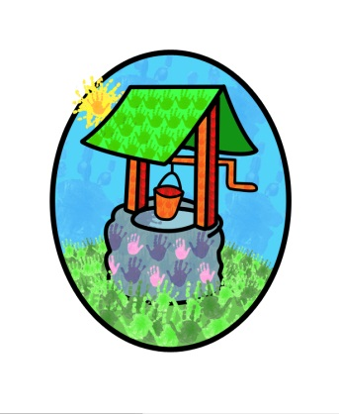

Jack and Jill Childcare … where children can explore, create and discover the colour of dreams

Sun Smart Policy:

Skin cancer is one of the most common cancers in the UK & the number of cases is rising at an alarming rate. The good news is that the majority of cases can be prevented.
Sunburn in childhood can double your risk of cancer. You will not see the damage immediately because skin cancer can take years to develop. But children who are exposed to the sun now are storing up problems for the future.

The five key sun smart skin cancer prevention messages are:
Stay in the shade 11-3
Make sure you never burn.
Always cover up – wear a t-shirt and hat. (Sunglasses may be worn where there is a medical reason to do so)
Remember children burn more easily.
Then use factor 15+ sunscreen.

At Jack & Jill, we feel it is important to raise the awareness of the need to be sun smart & will actively promote the above messages from April to September.
- Sun protection will be discussed interactively with the children.
- Parents & carers will be made aware of the importance of sun protection.
- Adults within the setting will be made aware of the importance of sun protection.
- Parents will be actively encouraged to provide a hat for their children.
- Children will be actively encouraged to wear a hat when outside.
- Parents will be actively encouraged to apply sunscreen prior to the start of the session.
- The outside environment will include shaded areas for the children to play.
- Parents will be actively encouraged to dress their children in tops which cover their shoulders.
- Children are permitted to wear sunglasses while in the outside environment, but do so at their own risk of loss or breakage

Parents are reminded to name all their children’s equipment & clothing.

This policy was adopted by Jack & Jill Pre-school at a meeting held on: 1st September 2014

It is signed on behalf of the setting by:

In their capacity as: Chairperson

