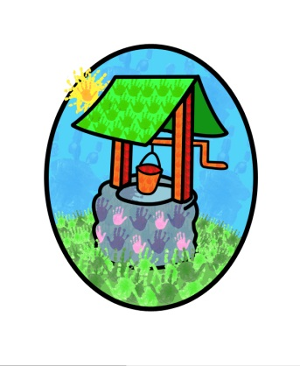
JACK Where children can explore, create and discover the colour of dreams
Privacy Statement
Setting Address: Littlehaven Infant School, Hawkesbourne Rd, Horsham, RH12 4EH
Northolmes Junior School, Leith View Rd, Horsham, RH12 4EA
Head Office: Littlehaven Infant School, Hawkesbourne Rd, Horsham, Rh12 4EH
Data Protection Officer: Diane Shanley

We are committed to ensuring that any personal data we hold about you and your child is protected in accordance with data protection laws and used in a manner that meets your expectations. This statement sets out what personal data we collect, how we will use it and how we will protect it.

What personal data do we collect?
We collect data about you and your child in order to provide care and learning opportunities that are bespoke to your child’s individual needs as well as that which allows us to verify and process free entitlement claims.

Children’s personal details include:
- Date of birth
- Name and address
- Health and medical information
- Care and development information
- Special educational needs
Were applicable this will also include information from other professionals such as:
- Child protection information
- Health care information
- Parental responsibility information and any relating court orders.

Parent / carer personal details include:
- Name
- Home and work address and phone numbers
- Emergency contact details
- Email address
- Family background
This information will be collected directly from you and will not be drawn from a third party.
If you are applying for free entitlement for your child we will also collect:
- National insurance number or Unique taxpayer reference number (UTR)
Were applicable it may be necessary for us to collect details of benefits and family credits

Why we collect your information and the legal basis for handling it
We use personal data about you and your child in order to provide childcare services and to fulfil the contractual arrangements. This includes:
- Making contact in an emergency
- Supporting your child’s development and wellbeing
- Managing any special educational, health or medical needs your child may have
- Carrying out regular assessments on your child’s development and identifying any areas of concern.
- Maintaining contact between you and the group to support parent partnership
- Processing claims for childcare funding, where applicable.
- Keeping you updated with information about our services.

With your consent, we will also record your child’s activities for their individual learning record. This may include photographs and videos. You will have the opportunity to withdraw your consent for images to be taken by confirming so in writing at any time.

We have a legal obligation to process safeguarding related data about your child should we have concerns about their welfare. We also have a legal obligation to transfer records and certain information about your child to the school that your child will be attending.

Who do we share your data with?
In order for us to deliver childcare services we will also share your data as required with the following categories of recipients:
- Ofsted – during an inspection or following a complaint about the service we are providing
- Banking services if processing direct debit / chip and pin payments (as applicable)
- Local authority – when making funding applications
- The governments eligibility checker (funding)
- Our insurance underwriter (if applicable)
- Our setting software management provider
- The school / setting your child will be attending.

We will share your data if:
- We are legally required to do so, for example by a court of law or the charity commission
- We need to enforce or apply terms and conditions from the contract you hold with us
- We need to protect your child or other children, for example by sharing information with the police or social services
- We need to protect our rights or property, or the rights / property of others
- We need to protect the safety of an individual or group of people
- The management of the setting is transferred in any way, to ensure the service you receive is continued.
We will not share your data with any organisation to use for their own purposes

How do we protect your data?
We protect unauthorised access to your personal data and keep it safe by:

- Storing information in a locked filing cabinet at the setting address: Hawkesbourne Rd, Horsham, RH12 4EH / Leith View Rd, Horsham, RH12 4EA
- Records stored on a computer are password protected

How long do we keep your data?
Data held for different reasons are retained for different lengths of time, please see our record retention policy for further information.
Your child’s learning journal and development records are given to you on request when your child leaves us and the online journals are deactivated.

Automated Decision Making
We do not make any decisions about your child based on any automated processes

Your Rights with respect to your data
You have the right to:
- Request access, amend or correct your/your child’s personal data
- Request that we transfer your / your child’s personal data to another person
- Request that we delete or stop processing your/your child’s personal data

Please contact us if you would like to discuss any of the information on this notice or you would like to exercise any of these rights.
If you are dissatisfied with our handling of your personal data and remain so following discussion with us you have the right to contact the Information Commissioner Office (ICO) using the details below:
Commissioner’s Office
Wycliffe House
Water Lane
Wilmslow
Cheshire
SK9 5AF

Ico.org.uk

This notice will be reviewed regularly and any changes will be notified to you where appropriate

