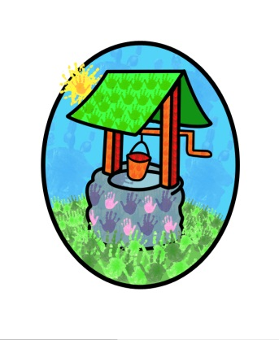
Jack and Jill Childcare

… where children can explore, create and discover the colour of dreams

Littlehaven Infant School
Hawkesbourne Rd
Horsham
RH12 4EH

TEL: 01403 258994
E-mail: office@jackandjillchildcarefacilities.com

Dear Parent/Carer,

It’s great to have you with us in September 2023. We look forward to sharing the year ahead with you and your child.

Your welcome pack contains:
- Dates for you Diary
- Payment policy
- Business Card – all our contact details on a handy card
- Loyalty Card – get your card stamped each time you join us for an ‘event’ and once your card is full you will receive a little gift.
- Colouring page
If applicable you will have a Free Entitlement document to complete and return before the end of term.

Check out our website (https://jack-jill.eschools.co.uk/website) for details of our stay-and-play family sessions. These are a great opportunity to become familiar with the setting and staff, as well as meet other families.

You may also be interested in our Little Chicks Parent and Toddler or Music Bus sessions, again please see our website for details.

Please don’t hesitate to contact us if you have any questions, we will be happy to help.

We look forward to welcoming you to Jack and Jill.

Kind regards

D Shanley

Diane Shanley

Childcare Executive
Jack and Jill Childcare Facilities

