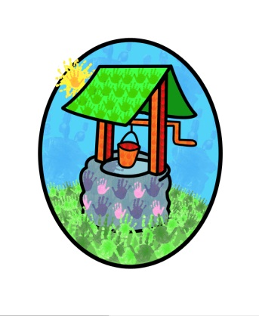

JACK … where children can explore, create and discover the colour of dreams
Packed Lunch Policy:

At Jack & Jill we promote the need for children to be encouraged to eat a balanced selection of foods that will fuel their whole body.
A healthy packed lunch is not only enjoyable & filling but can also provide several hours of sustainable energy.

We suggest the following points are kept in mind when preparing a child’s packed lunch:
- Using organic foods will expose your child to fewer undesirable added chemicals
- Basing your child’s lunch on starchy foods such as pasta, bread, rice & potato will provide them with sustainable energy
- Include some raw fruits & vegetables
- A balanced child’s meal should include protein; meat, fish, eggs, cheese & pulses will provide this.
- Avoid processed foods that may taste good but contain few nutrients & lots of undesirable fats, salt & sugar.
- It’s alright to include a small piece of cake or a biscuit, the children love to help you make these & this will allow you to make them from healthy recipes.

Food Safety
To keep food cool use an insulated lunchbox when possible & pop a pre-frozen icepack into it.

Packing a lunchbox
Remember to add a drink & appropriate utensils for the food you have included. A small piece of kitchen roll or a napkin is also useful for sticky fingers.
Please do not include sweets, fizzy drinks or glass bottles

Eating lunch
Our policy is that the children must finish all their savoury food before they are able to move on to pudding. The size & content of your child’s lunch may need to be reassessed & adjusted if they are not getting to their pudding on a regular basis.
Lunch boxes containing only sweet foods are not desirable.
Please note we are a nut free environment

This policy was adopted by Jack & Jill Pre-school at a meeting held on: 10th July 2015

It is signed on behalf of the setting by:

In their capacity as: Chairperson

