This is a tricky time for adults so how must our children be feeling?

Here are some activities to help them understand their thoughts and feelings about the COVID-19 crisis and the effect it is having on them and everyone they know.

- Feeling Faces – use any small bits of paper to draw simple faces on – happy, sad, cross, crying, worried etc. Look at them with your child, help them to use feelings words to describe the different faces. These faces can then be used to help your child share how they are feeling at different times
- People who love me – look at photos of relatives and friends that you cannot see at the moment. Talk together about the photos and memories you have.
- Friends and Family – make a simple book or poster together of the important people in your child’s life. You could use photos you already have or ask relatives and friends to send some , or you and your child could draw/make them – so long as your child can name them it doesn’t matter what they look like! Include pets if they have any. Talk about everyone, where they live, children or grown-ups, are they friends, cousins, aunts, grandads? You can return to this at anytime to add extra pictures, or tell a little story about one of them.
- Cosy place – it’s going to be hard to find quiet spaces to calm down or just ‘be’ when everyone is at home. Try to make a space with your child – a blanket or sheet over some string like a tent, under a table, a corner of the room. Add cushions and books or pen and paper. They could choose a special toy to be there too – remember to use this as a positive place.
- Send a song/message – if you have a mobile device, help your child to record messages for family and friends. Sing them songs or send messages and videos. Ask them to send the same back to your child.

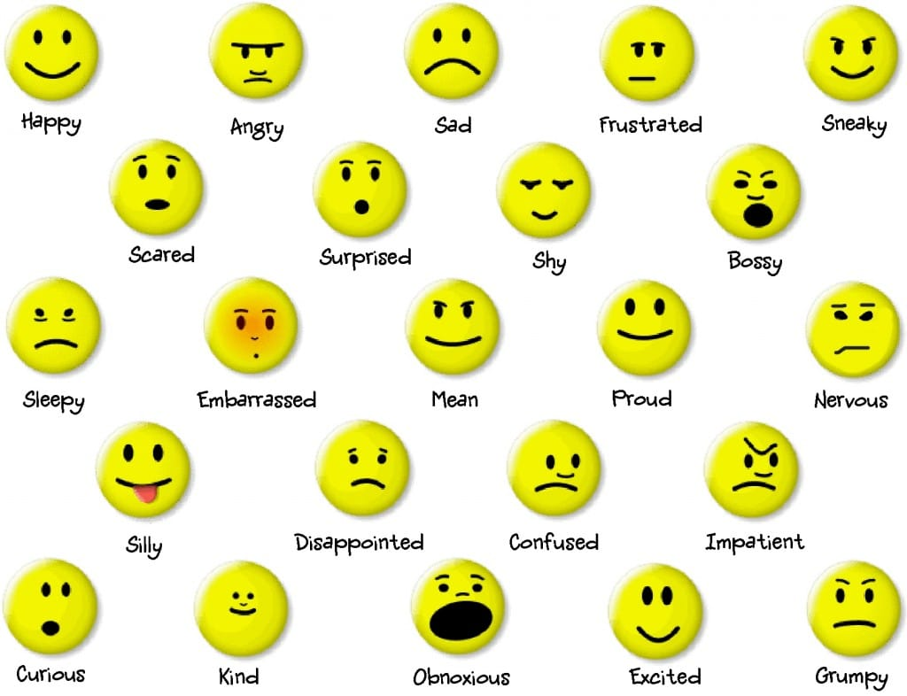
This Photo by Unknown Author is licensed under CC BY-NC

