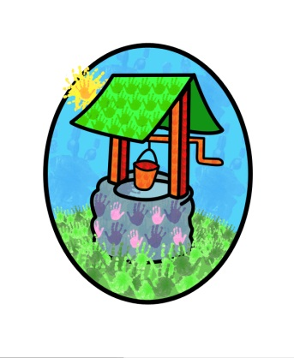

JACK … where children can explore, create and discover the colour of dreams

Inclusion Policy:
At Jack & Jill we feel that the well-being of children should be at the centre of the group’s ethos & that each child’s individual needs should be catered for within a rich, safe & stimulating environment.
We believe that no child, family or individual should be excluded from the group’s activities on the grounds of age, gender, sexuality, class, family status, means, disability, ethnicity, culture, religion or language.

We aim to provide an environment where:
- Staff are flexible, responsive & work as a team
- Accessibility has been carefully considered
- Planning is led by the interests of the children who are attending
- The ethos includes meeting the needs of children with additional needs
- All children are equally welcome to attend
- Visual stimuli such as posters & displays represent a diverse society
- Sound methods are used to communicate with parents
- All children are recognised as being unique
- Children feel they belong as part of the community
- All children are able to access a broad & balanced curriculum
- Qualities such as self-esteem & social skills as well as social integration & equality are positively supported & promoted
- Staff are able to liaise & communicate with outside professionals

Admissions:
The setting is open to every family in the community. The waiting list is operated on a system which takes into account the individual circumstances of the families accessing it.

Employment
We will employ the best person for the job & will treat all applicants with equal respect & opportunity. Commitment to the settings inclusion policy will form part of the job description for all employees.

Resources
These will be chosen to reflect our diverse society. Materials will be selected to support children in their development of self-respect as well as respect for others.
Equipment will be age & stage appropriate & will offer challenges to develop physical, personal, social & cognitive skills.
Equipment will conform to all relevant safety regulations & is sound & well made.

Discriminatory behaviour or remarks
These are completely unacceptable within the setting. In response we will aim to be sensitive to the feelings of the victim(s) & to encourage those responsible to understand & overcome their prejudices.

Language
Information, both written & spoken will be clearly communicated; we will endeavour to provide it in formats which reflect the needs of our members. We consider multilingual children & adults to be an asset & will value, recognise & respect their language within the setting.

Food
Medical, cultural & dietary needs will be met & a wide range of foods, reflecting healthy eating will be offered to the children.

Events & meetings
We will endeavour to be flexible with regard to their time and place, allowing access by families and staff. We will ensure they are conducted in ways which positively promote the inclusion of all the families attending the setting.

Additional needs
We aim to have regard for the Special Educational Needs and Disabilities Code if Practice: 0-25 years (DfE & DoH 2014)
- Children with additional needs are admitted to the setting following an assessment of their individual needs; this will be done in consultation with the family and external agencies where appropriate.
- The needs & progress of children with additional needs will be monitored by our inclusion and special educational needs co-ordinator (Diane Shanley)
- Our keyperson and SENCO / INCO support system will ensure that each child receives appropriate support.
- We aim to work closely with parents of all children in the setting to ensure that we draw upon the knowledge & expertise they are able to provide in planning provision for their children & discuss progress & achievements on a regular basis
- We will endeavour to seek additional support where appropriate to meet the individual needs of children
- Where appropriate we will liaise with relevant professionals & external agencies to help us meet children’s specific needs.
- Where appropriate we will refer children to the Horsham Hub in order to access support in providing for the child’s individual needs.
- We will be aware of the additional barriers that can exist when recognising abuse and neglect in children with Special Educational Needs
- Our staff will attend regular training on additional needs
- Disabled access will usually be given at the Littlehaven site

We feel that: ‘Inclusion is a process of identifying, understanding & breaking down barriers to participation & belonging.’ (Early childhood forum)

This policy was adopted by Jack & Jill Pre-school at a meeting held on:

It is signed on behalf of the setting by:

In their capacity as:

