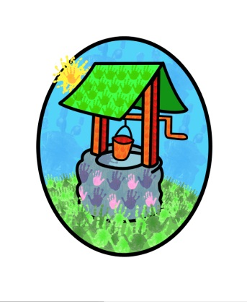
JACK … where children can explore, create and discover the colour of dreams

HO: Littlehaven Infant School
Hawkesbourne Rd
Horsham
RH12 4EH

TEL: 01403 258994
E-mail: jack.jillps@hotmail.co.uk

Jack and Jill’s Parent Questionnaire 2021

This report takes account of the collated feedback from the parent’s questionnaires 2021.

It outlines strategies for development and a timeframe to achieve them.

Report compiled by Diane Shanley on behalf of Jack and Jill

Introduction

Each year we ask our parent base to complete a questionnaire about their experiences at Jack and Jill. The information is collated and used to inform developments to our practice and provision. The aim of this process is to ensure we continue to provide a safe and stimulating environment for the children in our care and appropriate support for the children and their families.
The feedback information has been assembled into two categories to reflect the information individually for the pre-school and wrap-around provision. The information for the two sites has been combined to reflect the joint working (same site and staff team) that has been in place for much of the last year.
The collated response grids are available to view on our website or by request in the setting.

Response rates:
Wrap-around 37%
Pre-school 52%
The response rate has increased for wrap-around care since the last time the questionnaires were completed and fallen slightly for the pre-school provision.

Resulting Considerations:
Communicating and building relationships with parents and carers continues to be challenging in the current circumstances. We will continue to develop remote ways of communicating and encourage parents to engage with them.
The new EYFS has caused some confusion for parents. There is a section on the website to update them on this, but we need to look at additional ways of informing parents about the new processes.
There is a section on the website to help parents support their child’s learning at home, however the information isn’t necessarily being accessed by parents. Look at additional ways to inform parents about these strategies

Conclusion
The overall feedback from all sectors is very good.
The settings relationship with parents has been much more difficult to establish and maintain over the past couple of years.
The resulting strategies will be developed and reviewed regularly.
The collated results from the questionnaires and this report will be made available to the public via our website or can be requested from the setting.

