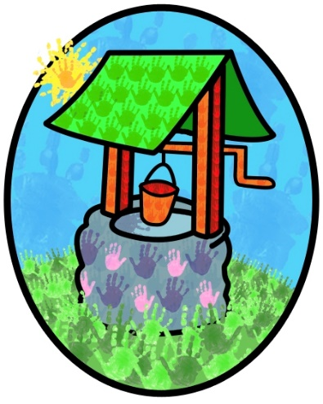
Jack and Jill Childcare

Registered Charity Number: 1042803

Where children can explore, create,
and discover the colour of dreams…

Hawkesbourne Rd
Horsham
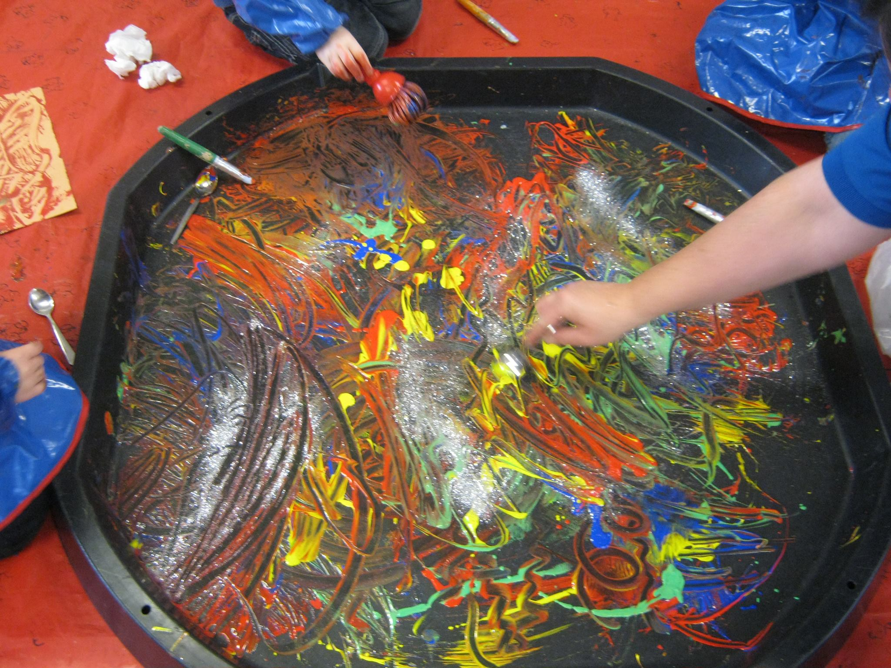
RH12 4EH
Tel: 01403 258994

Leith View Rd
Horsham
RH12 4ET
Tel: 01403 257492

Prospectus

Tel: 01403 258994
Email: office@jackandjillchildcarefacilities.com
Website: https://jack-jill.eschools.co.uk/website

June 2023
Welcome
Hello, and a warm welcome to Jack and Jill Childcare.
We understand how important it is to find the right care for your child. Whether you are looking for early years or wrap-around care, we hope our prospectus and website will provide all the information you need to make your decision.
Please don’t hesitate to contact us if you have any questions – we will be happy to help.

What we offer:
- A highly dedicated, passionate, and experienced staff team with relevant qualifications.
- Safe, secure, and clean environment with flexible and appropriate facilities.
- Child-led opportunities
- Extended opening- 7.30am to 6pm
- Early years and wrap-around care for children 9months to 10 years
- Flexible use of funding across our opening hours
- Healthy and nutritious meals cooked on-site
- Booking plans and ad hoc booking facility

Our philosophy:
- Children are best supported when parents and carers work together. A close partnership allows holistic development for individual children.
- Children need a safe, secure, and stimulating environment to explore within.
- Children need opportunities to develop positive relationships with adults and children.
- That children’s experiences, family background, interests, abilities and cultural heritage should be positively reflected in the setting.
- That children need to feel secure that their individual needs are being met.
- That networking with other professionals is a supportive practice that provides positive opportunities for all children.
- There is great value in promotion of the core development of communication, physical and social skills.

Learning and development:
At Jack and Jill the children themselves inspire the available learning opportunities through spontaneous play, exploration and creation within a safe and stimulating environment. The staff team extend the needs and interests of children to provide a flexible curriculum that promotes the development and wellbeing of individual children – children thrive when they are supported to give direction to their learning.

Ofsted Inspection-April ‘22(Littlehaven)
‘Staff create an interesting and stimulating environment, where children can explore and be curious. They provide experiences that build on children’s knowledge and skill and think carefully about what children need to learn next…’
‘Parents speak highly of the pre-school. They comment that staff are supportive and keep them well informed…’
‘Staff are calm and patient.’
‘Staff are highly sensitive to children’s individual needs’
‘Children are engrossed in their learning and benefit from hands-on experiences that build on their knowledge of the world… children are proud to take responsibility for these small tasks, which helps build their confidence and self-esteem.’
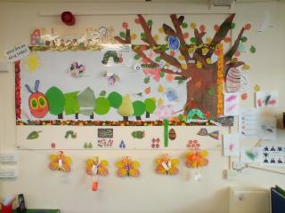
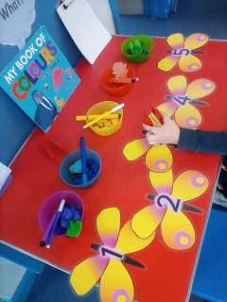

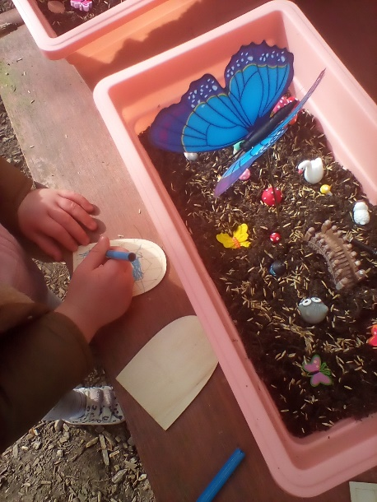
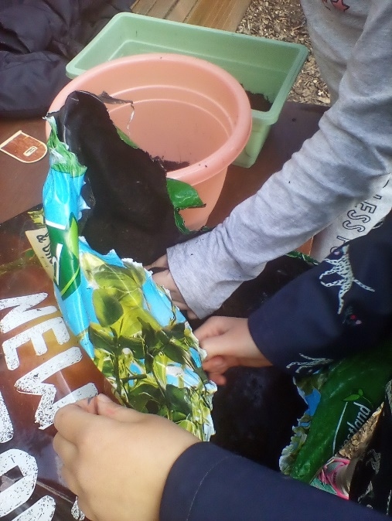
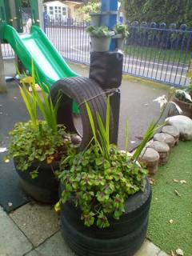
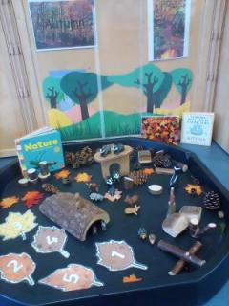

Early Years Foundation Stage:
The EYFS is central to our provision, and underpins the opportunities available to the children and their families:
- Parent partnership is a priority
- Children learn through play
- Progress is monitored and you receive regular updates
- Children are individuals and should be celebrated and supported as such

The curriculum is based on the Areas of Learning:

The Prime Areas
- Personal, Social and Emotional Development, including: Making relationships, Sense of Self, Understanding Feelings
- Communication and Language, including: Listening and Attention, Understanding, Speaking
- Physical Development, including: Moving and Handling, Health and Self-care
Prime areas of learning and development lay vital foundations and we consider them to take priority. These areas are embedded firmly at the core of everything we do.

The Specific Areas
- Literacy, including: Reading, Writing
- Mathematics
- Understanding the World, including: People and Communities, The World, Technology
- Expressive Arts and Design, including: Creating and Materials, Being Imaginative and expressive.
Specific areas of learning and development provide children with knowledge and skills to flourish in society. These are considered throughout the opportunities offered to the children.

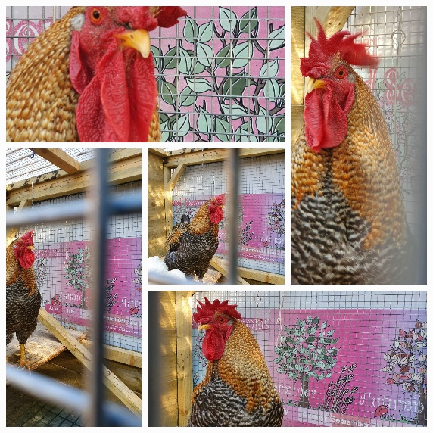
JACK Club (Wrap-around Care)
We provide wrap-around care before and after school for children form local schools.
- Littlehaven Infant School
- Northolmes Junior School
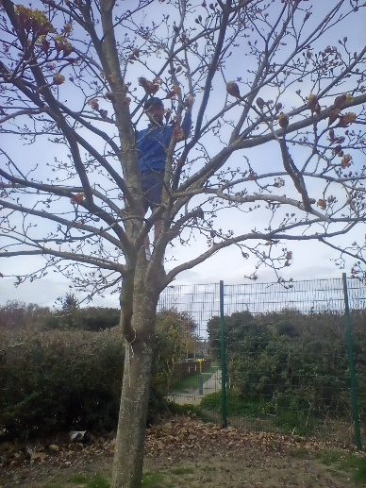
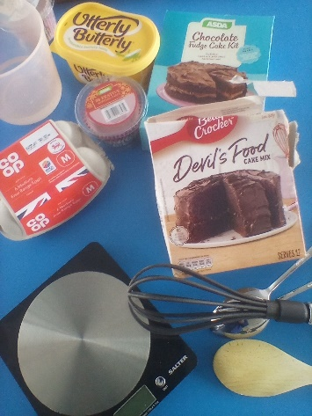
- Leechpool Primary School
Children have a wide range of opportunities available both indoors and outdoors. The safe environment gives them freedom and independence to explore, create and meet challenges- with staff on hand to help, support and guide them
Key Person
Each child is allocated a keyworker when they start at Jack and Jill. While we work collectively with all the children, the key person will take responsibility for monitoring your child’s progress, promoting their needs and interests within the curriculum and giving feedback to parents/carers through a variety of channels, including online, at consultation appointments and informal discussions at drop-off, collection and our regular stay and play events.
Arrival and Collection
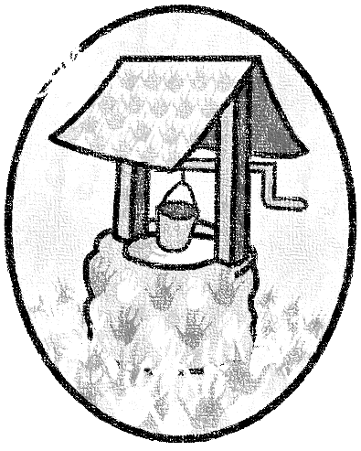
We work closely with the schools that we share premises with to ensure the safety and security of all children. This means that arrangements can be different at different parts of the day. Staff will make it clear how to access the setting according to your booking pattern. Both our sites have an intercom at the gate that allows you to talk to us

‘Our job is not to tell children what to be but to show them the possibilities of being’
Horatio Clare

See our website or contact us for more information or to request an application for admission.

Tel: 01403 258994 Email: office@jackandjillchildcarefacilities.com
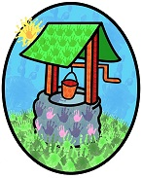
Website: https://jack-jill.eschools.co.uk/website

