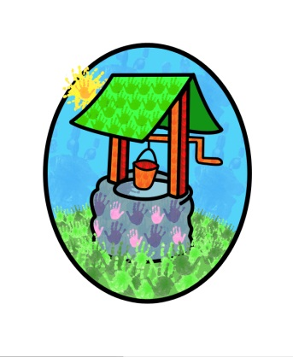
Jack and Jill Childcare

where children can explore, create, and discover the colour of dreams.

HO: Littlehaven Infant School
Hawkesbourne Rd
Horsham
RH12 4EH

TEL: 01403 258994
E-mail: office@jackandjillchildcarefacilities.com

Jack and Jill’s Parent Questionnaire 2023

This report takes account of the collated feedback from the parent’s questionnaires 2023.

It outlines strategies for development and a timeframe to achieve them.

Report compiled by Diane Shanley on behalf of Jack and Jill

Introduction

Each year we ask our parent base to complete a questionnaire about their experiences at Jack and Jill. The information is collated and used to inform developments to our practice and provision. The aim of this process is to ensure we continue to provide a safe and stimulating environment for the children in our care and appropriate support for the children and their families.
The feedback charts have been assembled into two categories to reflect the information individually for the pre-school and wrap-around provision.
We are only open on one site at this time so the information is related to the Littlehaven site.

Response rates:
Wrap-around 12%
Pre-school 51%
There has been a considerable decrease in the response rate for wrap-around care and a minor fall in the response rate for the pre-school families.

Resulting Considerations:
Communicating and building relationships with parents and carers continues to have its challenges. We will remain focused on developing a variety of communicating methods to meet the needs of all our families.
The new EYFS continues to cause some confusion for parents. This is reflected in outcomes to relevant questions about the way children’s progress is monitored and how development is supported. We need to provide an ‘easy to use’ overview for parents to use as a reference.
There is a section on the website to help parents support their child’s learning at home, however the information isn’t necessarily being accessed by parents. Look at additional ways to inform parents about these strategies.
The impact of difficulties with staff recruitment and absence rates can be seen in the amount of time available to spend on parent partnership, both online and face to face. It can result in parents feeling that they are ‘out of the loop’ and not receiving enough information or being kept up to date.

Conclusion
The overall feedback from all sectors is very good.
The setting needs to find new ways of getting information, that is already available into the focus of the attending families.
The setting needs to keep staff recruitment at the top of its priorities to ensure quality care, education and partnerships can be maintained and developed further.
The strategies resulting from this consultation will be reviewed by the trustees at their next meeting [March 2023] and reviewed regularly moving forward.

The collated results from the questionnaires and this report will be made available to the public via our website or can be requested from the setting.

