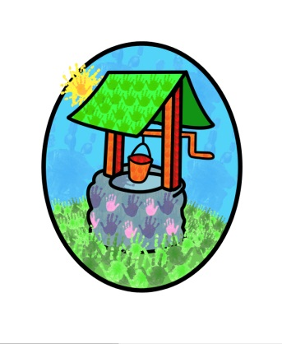

JACK … where children can explore, create and discover the colour of dreams

Social Development Policy:

At Jack & Jill we are committed to establishing a learning environment that promotes positive behaviour & relationships, where children & adults treat each other with care & respect.
We have an inclusive setting which supports all children as they take increasing responsibility for themselves & their actions, & consider the welfare & wellbeing of others.

The committee & manager will:
- Ensure that all staff have training in behaviour management
- Ensure that all staff, including students & volunteers, do not use any form of physical punishment
- Identify a member of staff with responsibility for behaviour management issues
- Share procedures for behaviour management with parents
- Ensure that physical intervention is only used where necessary to prevent children from causing harm to themselves, to others, or to property. All such incidents will be recorded & reported to parents
- Ensure that when responding to unacceptable behaviour, staff, students & volunteers, do not humiliate children or deprive them of food, warmth or comfort
- Arrange appropriate use of staff to support the children in developing relationships
- Actively promote high expectations of children’s behaviour within the setting

The staff team will:
- Organise the environment so it has a positive impact on behaviour in terms of space, access & activity choice
- Encourage appropriate behaviour in all interactions with children & adults, demonstrate that ‘good’ behaviour is valued
- Establish clear expectations & boundaries for behaviour, appropriate for the children’s level of understanding
- Identify & implement strategies that encourage positive behaviour
- Encourage the children to be aware of the settings routines & procedures
- Deal with negative behaviour at the earliest opportunity

Positive behaviour will be encouraged by:
- Use of praise specifically related to the children’s actions or behaviours
- If appropriate will focus the child’s attention to another activity
- Exploring activities which encourage sharing, negotiation & co-operation
- Encourage responsibility in caring for others & the environment
- Model appropriate behaviours in different contexts
- Demonstrate that the child is still valued, even if their behaviour is unacceptable
- Discuss with the children what is acceptable behaviour in different situations
- Encourage the children to express their feelings
- Help the children to understand the consequences & effects of their behaviour
- Support children to resolve conflicts with other children
- Support children’s self-esteem by enabling them to be successful in play experiences & activities

Behaviour management issues are dealt with by – Diane Shanley

This policy was adopted by Jack & Jill Pre-school at a meeting held on: 1st September 2017

It is signed on behalf of the setting by:

In their capacity as: Chairperson

