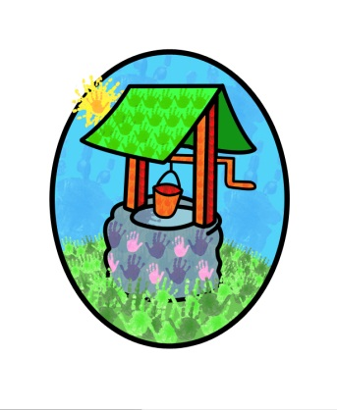

Jack and Jill Childcare Facilities
… where children can explore, create and discover the colour of dreams

Our philosophy:
- Children are best supported when parents and carers work together. A close partnership allows holistic development for individual children.
- Children need a safe, secure, and stimulating environment to explore within.
- Children need opportunities to develop positive relationships with adults and children.
- That children’s experiences, family background, interests, abilities and cultural heritage should be positively reflected in the setting.
- That children need to feel secure that their individual needs are being met.
- That networking with other professionals is a supportive practice that provides positive opportunities for all children.
- There is great value in promotion of the core development of communication, physical and social skills.

