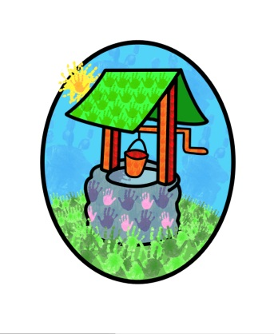
Jack and Jill Childcare

where children can explore, create, and discover the colour of dreams.

HO: Littlehaven Infant School
Hawkesbourne Rd
Horsham
RH12 4EH

TEL: 01403 258994
E-mail: office@jackandjillchildcarefacilities.com

Jack and Jill’s Parent Questionnaire 2024

This report takes account of the collated feedback from the parent’s questionnaires 2024.

It outlines strategies for development and a timeframe to achieve them.

Report compiled by Diane Shanley on behalf of Jack and Jill

Introduction

Each year we ask our parent base to complete a questionnaire about their experiences at Jack and Jill. The information is collated and used to inform developments to our practice and provision. The aim of this process is to ensure we continue to provide a safe and stimulating environment for the children in our care and appropriate support for the children and their families.
The feedback charts have been assembled into two categories to reflect the information individually for the pre-school and wrap-around provision.
We are only open on one site currently, so the information is related to the Littlehaven site.

Response rates:
Wrap-around 2.5%
Pre-school 53.33%
There has been a considerable decrease in the response rate for wrap-around care and a minor increase in the response rate for the pre-school families.
Resulting Considerations:
The new newsletter format of two letters a month, one for setting-based information and one for community-based information have been received positively. However, they are not reaching all families. They can be further developed to support home learning ideas and share the children’s in setting experiences and opportunities with parents and carers.
There is a section on the website to help parents support their child’s learning at home, however the information isn’t necessarily being accessed by parents. Look at additional ways to inform parents about these strategies.
The impact of difficulties with staff recruitment and absence rates, along with the increase of children’s individual and additional needs in the setting is impacting the time available to spend on parent partnership in general. It can result in parents feeling that they are ‘out of the loop’ and not receiving enough information or being kept up to date. The newsletters may help this to some degree, but ultimately, we need to look at recruitment, time management and reporting/recording systems to try and combat this shortfall.

Conclusion
The overall feedback from all sectors is very good.
The setting needs to find new ways of getting information, that is already available into the focus of the attending families.
The setting needs to keep staff recruitment at the top of its priorities to ensure quality care, education and partnerships can be maintained and developed further.
Continuous assessment, review, adaptation and flexibility is essential in maintaining partnership practices across all ages in the setting.
The strategies resulting from this consultation will be reviewed by the trustees at their next meeting [March 2024] and reviewed regularly moving forward.

The collated results from the questionnaires and this report will be made available to the public via our website or can be requested from the setting.

