

Jack and Jill Childcare… where children can explore, create
and discover the colour of dreams

Funded Entitlement Policy:

Early Years Funded Entitlement (EYFE) is Government funding allowing all eligible children to access funded early years education and childcare. EYFE is available to:
• some 2-year-olds (2-year-old LA Issued EYFE
• all 3- and 4-year-olds (Universal EYFE);
• children from as early as 9 months old who meet the eligibility criteria for EYFE for Working Families.
Some 3- and 4-year-olds are eligible for an extra 570 hours per year, Extended EYFE for Working Families.
There are several types of EYFE funding (see the table below). From September 2025, all children eligible for EYFE for Working Families can access up to 1,140 hours per year.
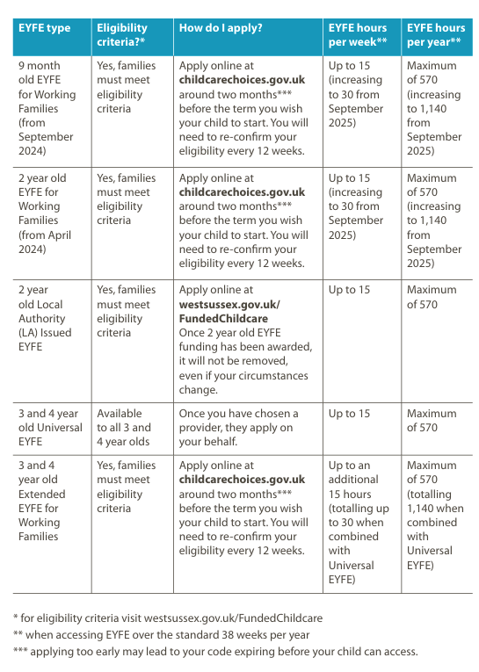

We provide flexible allocation of funding which can be used across all our sessions.
Additional costs are incurred for meals, ad hoc sessions and additional sessions to the funded allocation.
Children must be attending the setting prior to headcount day (usually in the first two weeks of the start of term) to be eligible.

To receive EYFE we will ask you to complete & sign a parent declaration form, providing proof of your child’s date of birth. Any changes must be agreed prior to headcount day to be eligible as part of the EY FE.

Families meeting the criteria may be able to apply for 15/30 hours Funded Entitlement for two-year-olds. Check www.westsussex.gov.uk/freechildcare

Eligible children can access Funded Entitlement, take a look at the website www.childcarechoices.gov.uk for details.

This policy was adopted by Jack & Jill Pre-school at a meeting held on: 1st September 2024

It is signed on behalf of the setting by: Lynne Batchelor
In their capacity as: Chairperson

