**Music and Singing**

**Your child is learning:**

To move their bodies to sounds they enjoy.

To listen to and join in with rhymes and songs.

To create their own sounds.

**Role of the Adult:**

To help your child discover what noises objects …..……………………………… and their bodies and …….……………... voices make

**…………………………………. At home you could: ……………………..** Dance to music. …………………………………... Sing songs together.

Make different noises using items from around the home i.e. pots and pans.

Make bottle shakers – fill bottles with dry rice, pasta, counters etc.

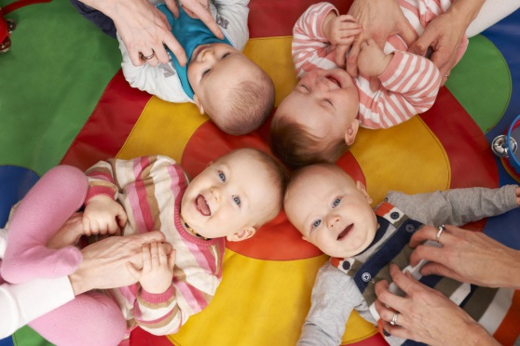

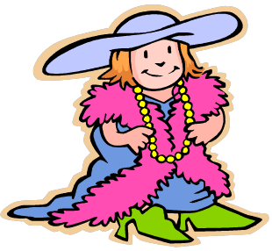

**Dressing Up**

**Your child is learning:**

Self-help and physical skills,

such as doing up fastenings

and stepping into items of

clothing.

**Role of the Adult:**

Encourage your child to dress and undress themselves independently, lending a helping hand only when needed.

**At home you could:**

Provide real life everyday objects to support their role play such as hats, purses or bags. Encourage dressing up skills with ordinary clothing.

**Role Play**

**Your child is learning:**

To make sense of their world by re-living first hand experiences through play, for example going to the shops.

**Role of the Adult:**

Wait until your child invites you into the play and gives you a role i.e. “I’m going to be the mummy and you can be the shop keeper.” Join in the play by taking on the role they give you.

**At home you could:**

Provide real life everyday objects to support their role play, for example old purses and bags.

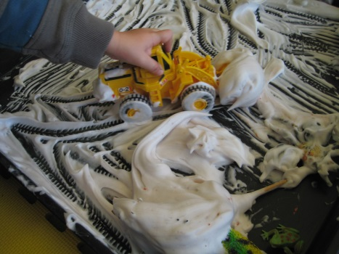

**Messy Play**

**Your child is learning:**

Children learn through all their senses, exploring the texture, smell (and taste!) of materials.

**Role of the Adult:**

Explore the materials with your child, talking about how they look, smell and feel. Use fun words to describe your play such as ‘squidge’, ‘gloop’, ‘splodge’, ‘splash’.

**At home you could:**

Explore some messy play

such as cooked spaghetti,

shaving foam and corn

flour and water.

**Books**

**Your child is learning:**

To enjoy books and reading. They learn that words carry meaning, and stories help develop their imaginations

**Role of the Adult:**

Share books with your

children.

As well as reading the

words you can tell a story

just using the pictures.

**At home you could:**

Visit the local library to borrow books.

Make a regular quiet, relaxed book sharing time, such as bedtime.

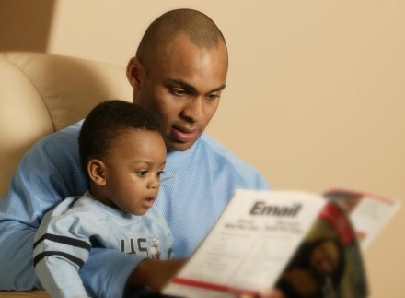

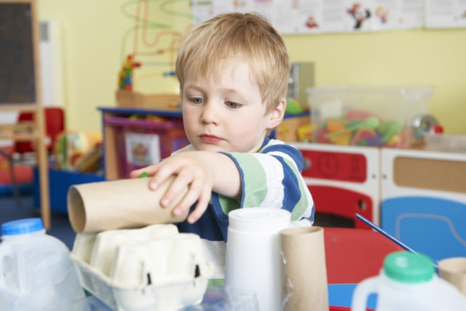

**Junk Modelling**

**Your child is learning:**

To create and explore different materials. To explore ways to stick items together. To explore different tools such as scissors, tape, staplers etc.

**Role of the Adult:**

To talk about what

your child is making

and the design choices

they have made. Assist with tricky materials.

**At home you could:**

Collect old cardboard boxes, tubes and bottles and let your child construct using them.

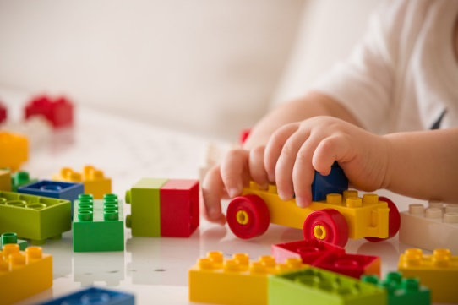

**Construction**

**Your child is learning:**

To join construction pieces together to build and balance using their knowledge of shape, space and size.

**Role of the Adult:**

To talk about what

your child is building

and play alongside

them i.e. “I have

made a tall tower, I wonder if you can build a taller tower!”

**At home you could:**

Collect old cardboard boxes, tubes and bottles and let your child construct using them.

**Mark Making**

**Your child is learning:**

Large mark making helps children develop the muscles and skills needed for writing.

They are learning that marks carry meaning. They are exploring the shapes and marks different objects make

**Role of the Adult:**

Talk to your child about

different patterns and

marks objects make

**At home you could:**

Use big pens to draw on big paper

Use water and paint brushes on walls outside

Mark make with fingers in a tray of flour

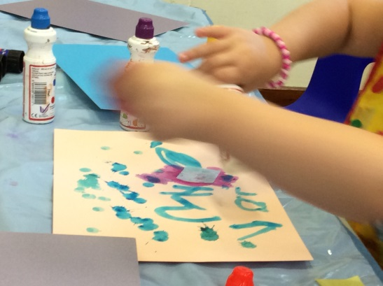

**Outside Play**

**Your child is learning:**

All about the outside world using all their senses! They will hear wildlife and traffic, see the changing

seasons, and feel the

weather. They also

have an opportunity

to move their body in

different ways (running, climbing, sliding)

**Role of the Adult:**

Talk about what you and your child can see, hear and feel – the wind, crunchy fallen leaves, and birds singing.

**At home you could:**

Go for walks, visits parks and beaches, have picnics in the garden



**ICT**

**Your child is learning:**

About all the gadgets we use, from computers and tablets to remote controls and torches

**Role of the Adult:**

Show and explain to the child how the technology works and why you use it.

**At home you could:**

Spend some time together on a laptop or tablet playing educational games, show them how to take pictures on mobile phones or cameras

**Investigative Play**

**Your child is learning:**

To find new ways of solving problems. They are learning to try again if things don’t as they planned, and exploring how things work.

**Role of the Adult:**

Allow your child space to explore but do step in and support if things get too tricky or frustrating.

**At home you could:**

Explore melting ice (or snow!) with different resources or techniques

**Small World**

**Your child is learning:**

To make sense of their world by re-living first hand experiences through play, for example playing ‘mums and dads’ with play figures

**Role of the Adult:**

Wait until your child invites you into the play and gives you a role i.e. “I’m going to be the mummy and you can be the baby”. Join in the play by taking on the role they give you.

**At home you could:**

Get into character with any resources to hand – Lego, dolls, animals, trains or even make your own peg dolls!

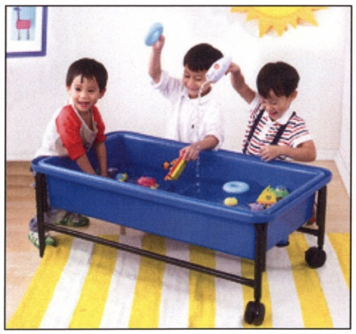

**Water Play**

**Your child is learning:**

That some objects float and others sink, and some containers hold more than others.

**Role of the Adult:**

Use language such as floating, sinking, full and empty.

**At home you could:**

Provide toys and

containers for them

to play with in the

bath, or even get

them to help with

the washing up!