Fruit pie with ice-cream, or you could choose custard?  Sample Menu  Monday: Cheese and tomato pasta bake  Jelly and ice-cream  Tuesday: Shepherd’s pie  Fruit crumble with ice-cream  Wednesday: Chicken pie with mash and veg  Cake finger with yoghurt  Thursday: Jacket potato and choice of filling  Pancake with choice of topping  Friday: Chicken Curry with rice  Fresh fruit salad with shortbread |  |  | Hot Lunches  We offer your child the opportunity to have a hot meal at lunch time. All meals are cooked fresh on the premises.  Our working practices in relation to the preparation, cooking and serving of food will be based on the guidance provided in:  ‘Safer food, better business for caterers’  And  The Children’s Food Trust, Eat Better Do Better. Voluntary Food and Drink Guidelines  Contact Us  Phone: 01403 258994  Email: jack.jillps@hotmail.co.uk  Web: jackandjillps.co.uk  Jack and jill Pre-school |  |  | 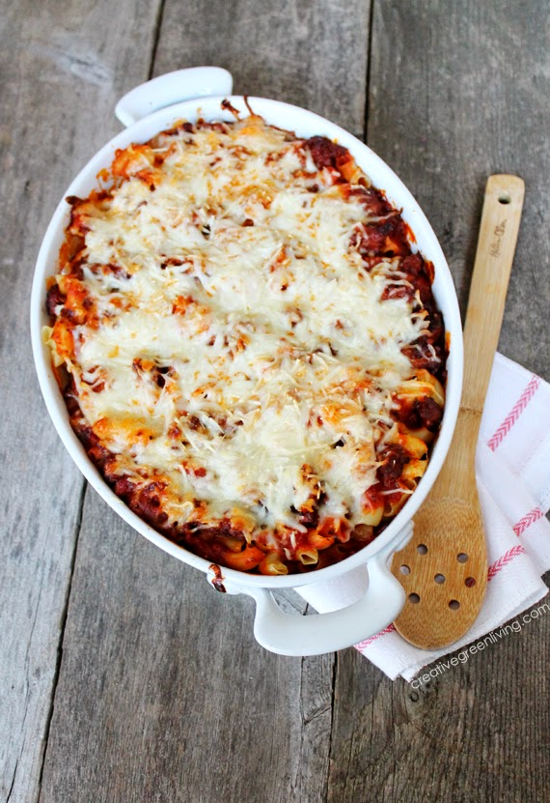  Jack and jill Pre-school  - Hot Lunches

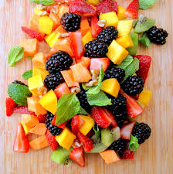  How can I book and how much does it cost?  Meals are invoiced in advance. Once booked we will continue with the order until you notify us of any changes  Meals are £2.25 each and are payable in advance  Simply complete and return the booking form to reserve your child’s lunch, give us a call or drop us an email  Cancellation:  In order to receive a refund for meals when your child is absent from the setting we must be notified of the absence no later than 3pm on the Friday before the absence. |  |  | Hot Lunch Booking Form  Child’s name:  I wish my child to have hot lunches on the following sessions  Monday  Tuesday  Wednesday  Thursday  Friday  Please jot any comments you wish here:  ‘What could be more important than a little something to eat’  Winnie the Pooh  m |  |  | Jacket potato with a choice of fillings  Food will be prepared and cooked on site daily  Each day an alternative of bread and butter will be available for your child.  Each meal will be served with a choice of milk or water  All meals are suitable for vegetarians or have a vegetarian options  If you need to discuss your child’s dietary requirements, such as lactose intolerance, please let us know  All meals are subject to change  Menus will be published on the website

