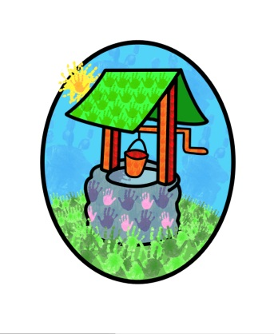
JACK … where children can explore, create and discover the colour of dreams

HO: Littlehaven Infant School
Hawkesbourne Rd
Horsham
RH12 4EH

TEL: 01403 258994
E-mail: jack.jillps@hotmail.co.uk

Jack and Jill’s Parent Questionnaire 2020

This report takes account of the collated feedback from the parent’s questionnaires 2020.

It outlines strategies for development and a timeframe to achieve them.

Report compiled by Diane Shanley on behalf of Jack and Jill

Introduction

Each year we ask our parent base to complete a questionnaire about their experiences at Jack and Jill. The information is collated and used to inform developments to our practice and provision. The aim of this process is to ensure we continue to provide a safe and stimulating environment for the children in our care and appropriate support for the children and their families.
The feedback information has been assembled into four categories to reflect the information individually for the Northolmes and Littlehaven sites and the pre-school and wrap-around provision.
The collated response grids are available to view on our website or by request in the setting.

Response rates:
Littlehaven Pre-school 79.1%
Littlehaven Wrap-around 23.5%
Northolmes Pre-school 66.6%
Northolmes Wrap-around 27.3%
The response rate has increased since the last time the questionnaires were completed, with exception of Littlehaven Wrap-around care which fell slightly.

Resulting Considerations:
We will be developing a Healthy Start Statement in the new year (2021) this statement will include supporting the children and families with healthy eating, physical activity, and emotional well-being. It will form the backbone of our provision and will be communicated with families.
Communicating and building relationships with parents and carers is particularly challenging at the moment, but we will continue to develop remote ways of communicating. We are committed to reinstating our usual activities such as ‘stay-and-play’ sessions as soon as we are able and will continue to monitor the situation accordingly.
We have started a programme of including information about elements of our practice in the newsletter each month and will make behaviour management one of our topics in the coming three months. This will give parents the opportunity to read about our positive reinforcement strategies and to point them to the behaviour management section of the website.

Conclusion
The response rate has improved, particularly with the pre-school section of the parent base.
The overall feedback from all sectors is very good.
The resulting strategies will be developed and reviewed regularly.
The collated results from the questionnaires and this report will be made available to the public via our website or can be requested from the setting.

