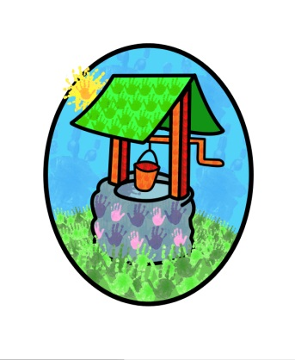
Jack and Jill Childcare

… where children can explore, create and discover the colour of dreams

Littlehaven Infant School
Hawkesbourne Rd
Horsham
RH12 4EH

TEL: 01403 258994
E-mail: office@jackandjillchildcarefacilities.com

June 2023

Dear parents/carers,

We are currently collating our registers for the academic year 2022/23 and have noted that your child is on our waiting list for the coming year.

We have attached the relevant documents for you to complete and return.
Once we receive the documents you will get confirmation of the booking and a link to their online account. When you have activated your account, please check the details.

We ask that the completed documents are returned to us by 30th June 2023.

Please don’t hesitate to contact us via email if you have any questions.

Kind regards

Diane Shanley

Childcare Executive
Jack and Jill Childcare Facilities

