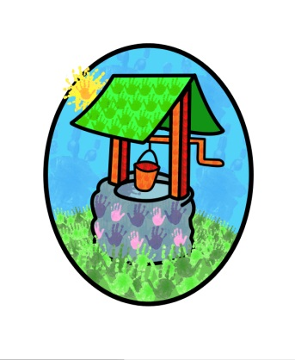 Jack and Jill Childcare

… *where children can explore, create and discover the colour of dreams*

Littlehaven Infant School

Hawkesbourne Rd

Horsham

RH12 4EH

TEL: 01403 258994

E-mail: [office@jackandjillchildcarefacilities.com](mailto:office@jackandjillchildcarefacilities.com)

Dear parents / carers,

Firstly, I would like to apologies for the lateness of the following information. We have been involved in conversation with West Sussex County Council for the past eight months and we have been unable to confirm the what, where and why for Jack and Jill following the announcement that Littlehaven and Northolmes would be amalgamating to create the new Oakfields Primary School, legally from September 2025 and physically from September 2026.

We are really pleased to confirm that we are now developing a plan to extend our current building at Northolmes allowing for all our provision, Nursery, Pre-school, and Wrap-around to be housed on one site alongside the new school.

Over the coming academic year, we plan to design and build our new premises. 😊

Unfortunately, this project is too large to be completed outside of term time, and we do not want children being cared for in a building site. This means that we need to adapt our provision for the coming year. From September (2025) we will be running all our provision from the Littlehaven site – closing the Northolmes site temporarily to allow unrestricted access by the building team and to ensure the safety of the staff and children.

Adaptations to the spaces we have available across two + classrooms at Littlehaven will take place over this summer, resulting in designated spaces for our 9-month + children, our 2–3-year-olds, our 3–4-year-olds and the children attending wrap-around sessions for the coming academic year. In addition, we will have plenty of space outside including our garden, and the playground and field through the day to ensure the children can engage in outdoor and physical play throughout the sessions.

If you have any questions or concerns, please don’t hesitate to get in touch.

Our first Stay-and Play session of the new academic year will be Saturday 13th September between 10am and 12noon, this will be an opportunity to see how the space has been divided and know where your child’s sessions are housed.

We hope to be able to update you very soon with more details about the project – busy, but exciting times ahead 😊

Kind regards

Diane Shanley